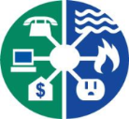
Utility Payment Conference
Planning Committee

Meet the Utility Payment Conference Planning Committee

We are happy to announce our 2018 Utility Payment Conference Planning Committee Members.

Orlando Utilities Commission Las Vegas Valley Water District NorthWestern Energy
2018 Honorary Host – Janet 2017 Host - Karen Nikki
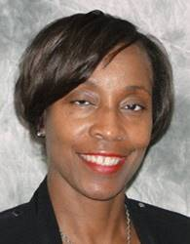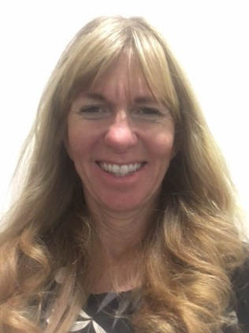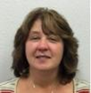

Southern California Gas Company Vectren Washington Gas (D.C)
Debbie Teresa Peter

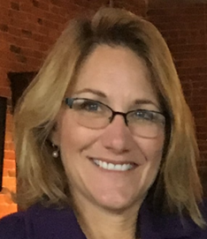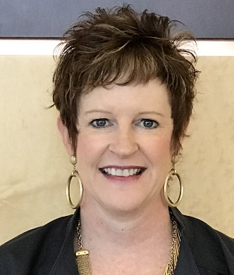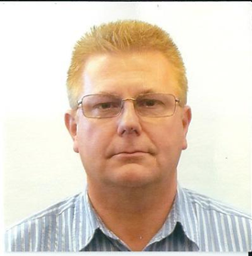

Duke Energy UPC Booth/AV Coordinator
Jeff Derek

